Apache Hadoop Installation on Linux

$sudo apt-get update
$sudo apt-get upgrade

Step 1:-Click to download the Java 8 Package. Save this file in your home directory.
Command :-sudo apt-get install default-jdk

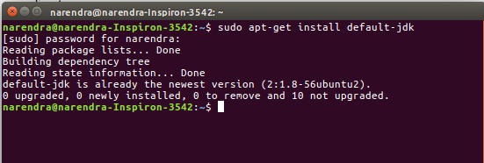

Step 2:-check the java version
Command : java -version
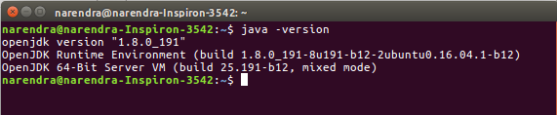

Step 3:-ssh is Secure shell. This application allows us to get remote access of any machine(or Local host) by different password other then root and alsoallows us to bypass the password by setting it to empty. To install ssh use following command

Command :- sudo apt-get install ssh

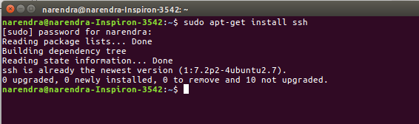
Step 4:-you will be ouput
Command :- ssh localhost
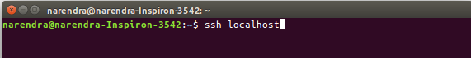
Step 5:-Please note that there is two single quotes after 'P' in command without space. After entering this command it will ask “Enter file in which to save the key (/home/narendra/.ssh/id_rsa):” press Enter without typing any single word. You will get Image after entering this doing this, this image is called as randomart image. This image will vary machine to machine and this key will be used to communicate between any two machine for authentication.This command will create an RSA key pair with an empty password.Generally, using an empty password is not recommended, but in this case it is needed to unlock the key without your interaction (you don’t want to enter the passphrase every time Hadoop interacts with its nodes).
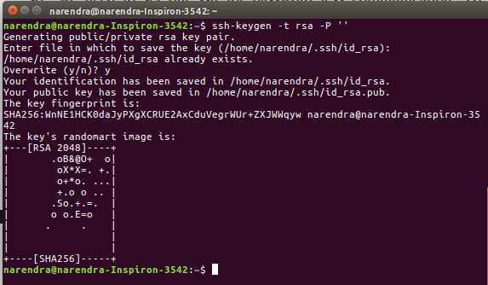
Command :-ssh-keygen -t rsa -P ' '

Step 6:-Now we need to save this generated key to local machine’s host key fingerprint to the user’s known hosts file. To do this use this command.
Command :-cat $HOME/.ssh/id_rsa.pub >> $HOME/.ssh/authorized_keys

Step 7:-if this step asks you for a password that means you have done something wrong. So to repair this you need to repeat the above steps from next to installing ssh again.
Command :-ssh localhost
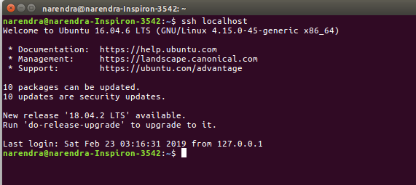
Step 8 :-Download the Hadoop 2.6.0 Package

Commnad :- wget https://archive.apache.org/dist/hadoop/core/hadoop-2.6.0/hadoop-2.6.0.tar.gz
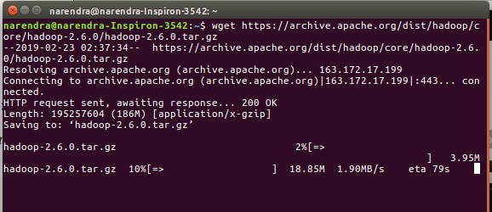
Step 9:-Extract the Hadoop tar File.

Command :- ls

Command :-tar -xzvf hadoop-2.6.0.tar.gz
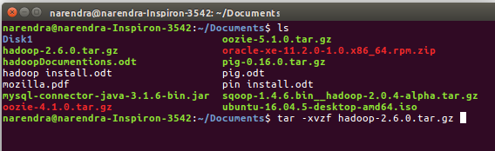

Step 10:-hadoop file move usr/local/hadoop

Command :-sudo mv Desktop/hadoop-2.6.0 /usr/local/hadoop

Step 11 :- Add the Hadoop and Java paths in the bash file (.bashrc).
Open. bashrc file. Now, add Hadoop and Java Path as shown below
Command :-gedit ~/.bashrc

#Hadoop variables
export JAVA_HOME=/usr/lib/jvm/java-8-openjdk-amd64
export HADOOP_INSTALL=/usr/local/hadoop
export PATH=$PATH:$HADOOP_INSTALL/bin
export PATH=$PATH:$HADOOP_INSTALL/sbin
export HADOOP_MAPRED_HOME=$HADOOP_INSTALL
export HADOOP_COMMON_HOME=$HADOOP_INSTALL
export HADOOP_HDFS_HOME=$HADOOP_INSTALL
export YARN_HOME=$HADOOP_INSTALL
#end of Hadoop variable declaration

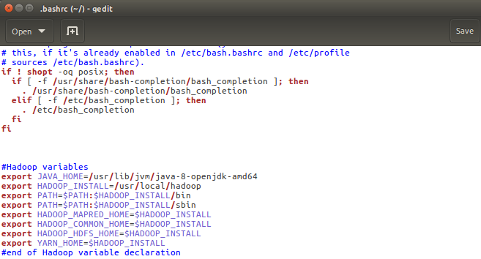

Step 12:-check the hadoop version

Commnad :-Source ~/.bashrc

Command :-hadoop version

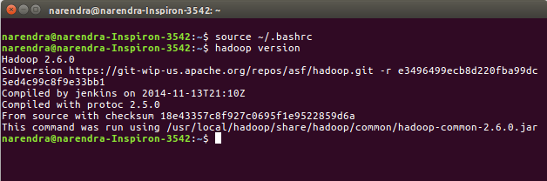

Step 13:-hadoop-env.sh file edit java path. The java implementation to use.

Command :- /usr/local/hadoop/etc/hadoop-env.sh
Path edit :-export JAVA_HOME=/usr/lib/jvm/java-8-openjdk-amd64
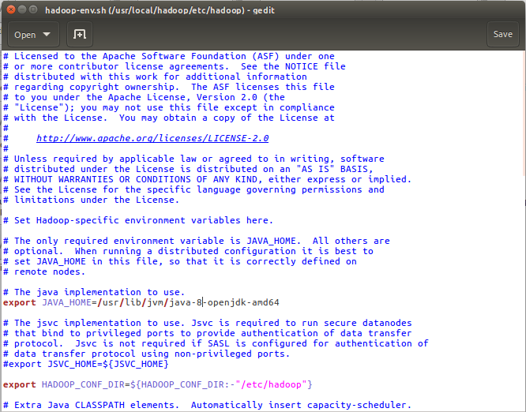

Step 14:-To configure hadoop in Pseudo Distributed mode we need to edit following files

1)core-site.xml
2)hdfs-site.xml
3)mapred-site.xml
4)yarn-site.xml

1 :-core-site.xml
<property>
<name>fs.defaultFS</name>
<value>hdfs://localhost:9000</value>
</property>
<property>
<name>hadoop.tmp.dir</name>
<value>/home/narendra/tmp</value>
</property>
2 :-hdfs-site.xml
<property>
<name>dfs.replication</name>
<value>1</value>
</property>
<property>
<name>dfs.namenode.name.dir</name>
<value>/home/narendra/tmp/namenode</value>
</property>
<property>
<name>dfs.datanode.data.dir</name>
<value>/home/narendra/tmp/datanode</value>
</property>

3 :-mapred-site.xml
<property>
<name>mapreduce.framework.name</name>
<value>yarn</value>
</property>

4 :-yarn-site.xml
<property>
<name>yarn.nodemanager.aux-services</name>
<value>mapreduce_shuffle</value>
</property>

Step 15:-Before starting hadoop we need to format our namenode. Execute this command to format namenode.

Command :- $hdfs namenode-format

Now to start hadoop you can use two command

Command :- $start-dfs.sh

Command :- $start.yarn.sh

Or you can also use deprecated command as

Command :-start-all.sh

Command :-stop-all.sh

To check the which components are working you can use bellow command

Command :- jps

